Inflow and Infiltration – What you need to know and what you can do
Inflow and infiltration (I/I) is clear water – such as groundwater and surface water - that enters the wastewater system from sources such as defective sewer service laterals, poor pipe connections, sump pumps, gutters/downspouts, building drains, and aged or broken sewer main and maintenance hole covers. When clear water enters the wastewater system it needs to be treated at a wastewater treatment plant. During rain events, I/I adds significant amounts of clear water to the wastewater system that it was not intended to accommodate or treat.
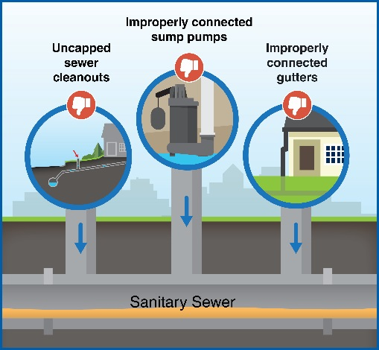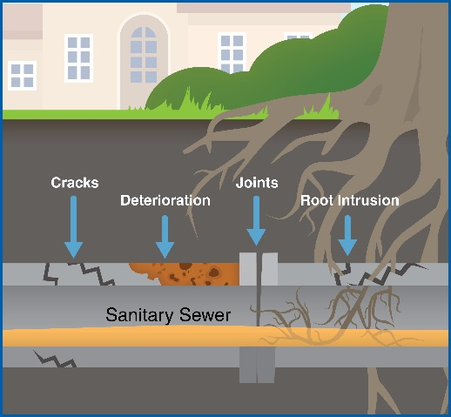

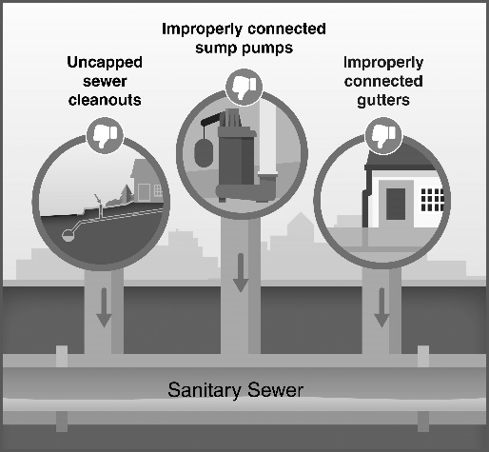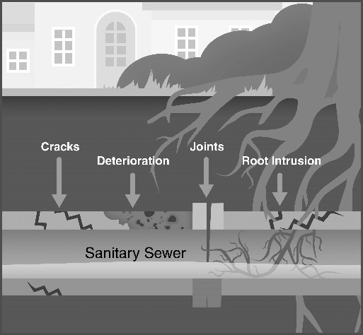
The clear water in the sewer system reduces the capacity of city sewer pipes, regional interceptors, and treatment facilities. In the end, this requires additional funding to enlarge existing facilities or construct new facilities at the local and regional level. Costs for larger facilities in the Twin Cities is estimated to be in the billions of dollars. Reducing I/I will lessen future costs for additional infrastructure and keep utility rates and fees at some of the lowest rates in the nation.
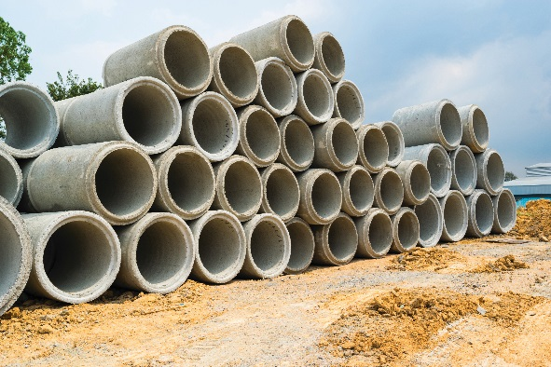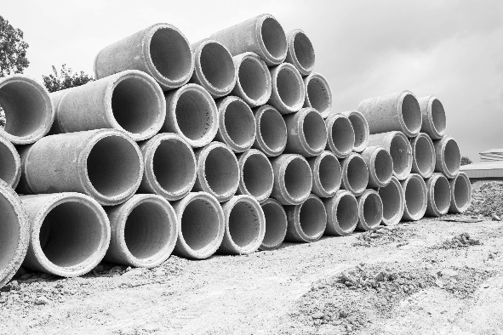
Excessive I/I in the wastewater system can impact your health and decrease the value of your property. A wastewater system that is over capacity due to I/I can lead to sewage backups into basements and sewage overflows into lakes, streams, wetlands or other environmentally sensitive areas. Additionally, the resale value of a property can be reduced if problems exist in the building’s sewer service lateral – the sewer pipe from a building to the city’s sewer main.
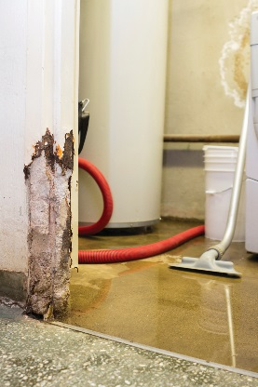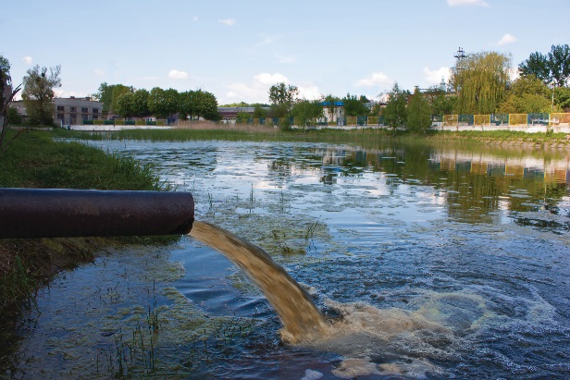

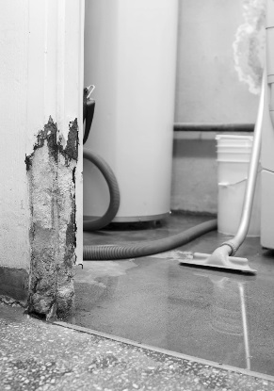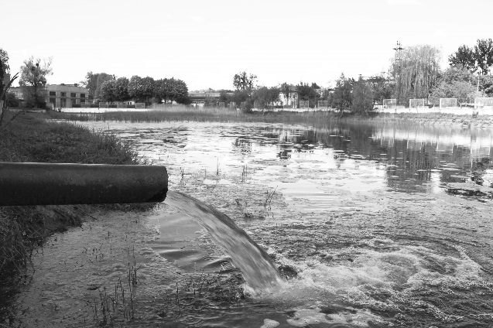
Property owners can reduce I/I to the sewer system by:
- Properly connecting sump pumps and gutters/downspouts
- Having a plumber inspect the sewer service lateral from your building to the city sewer main for cracks, deterioration, or tree root intrusions
- Making repairs to your sewer service lateral
