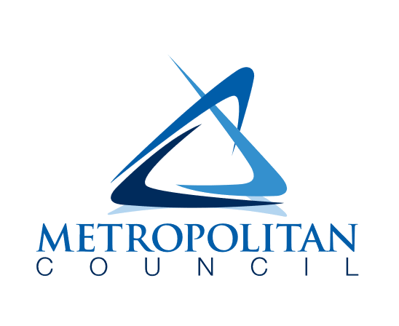
Private Property Inflow & infiltration grant program
Application for Participation - 2024

Information
This form provides the basis for entering into an agreement with the Metropolitan Council Environmental Services (Met Council, ES) for the Private Property Inflow & Infiltration (I/I) Grant Program for 2024. Completion of this form and its attachments confirms your municipality’s intention to participate and verifies that the municipality has performed all required activities to receive grant funding for private residential I/I mitigation work.

More information on the grant program, including program guidelines, can be found at the following link:
https://metrocouncil.org/Wastewater-Water/Funding-Finance/Available-Funding-Grants/Private-Property-Inflow-and-Infiltration-Grants.aspx

Grant Application

Municipality Name: Click or tap here to enter text.

Date: Click or tap to enter a date.

Designated Contact (all correspondence and municipality responsibility regarding participation in the program should be addressed to the individual named below):

Name: Click or tap here to enter text.
Address: Click or tap here to enter text.
Phone Number: Click or tap here to enter text.
Email: Click or tap here to enter text.

Requested Grant Amount: Click or tap here to enter text.
*Recent data suggests an average lining cost of $8,000 per sewer lateral

A resolution from Council confirming this individual’s authority and certification that they have read the program guidelines and support participation in the program must be submitted.

Is a resolution attached: ☐Yes ☐No

Do you plan to solicit bids from MCUB businesses? ☐Yes ☐No

☐Check here for acknowledgement of Met Council MCUB approved businesses list.

If you plan to consider an equity component in your grant fund distributions, please provide a statement explaining how you plan to do this:
Click or tap here to enter text.

Please provide a statement explaining how you plan to do outreach and communication to reach private property owners.
Click or tap here to enter text.

What, if any, outreach and communication support would be helpful to receive from Met Council?
Click or tap here to enter text.

