METROPOLITAN COUNCIL LIVABLE COMMUNITIES

TAX BASE REVITALIZATION ACCOUNT
PILOT GRANT APPLICATION GUIDE
2015
Pilot Grant Application Guide Topics ii
What is the purpose of TBRA grants? ii
ELIGIBLE APPLICANTS and QUALIFYING SITES ii
Who is eligible to apply for a TBRA grant? ii
What type of redevelopment sites are eligible to compete for a grant? iii
ELIGIBLE and INELIGIBLE USE OF GRANT FUNDS iv
Quality of Assessments and Cleanup Plans v
Additional Factors Affecting Cost Eligibility vi
When can I incur costs to be paid using grant funding? vi
Grant Timeline vii
Other Requirements vii
Matching funds vii
Affordable Housing ix
Residential Marketing Plans ix
AWARDING GRANTS/COMPETITIVE PROCESS ix
Funding Limits xi
LOCAL SUPPORT xi
REPORTING REQUIREMENTS xi
PROCEDURES and PERMISSIONS xi
How do I apply? xi
Use of Application Images xii
Appendices and Attachments xiii
Appendix A: Enabling Legislation and Requirements for Participating Cities: xiii
Appendix B: Using WebGrants Online Application Forms xiv
Appendix C: Using Make-a-Map xv
Attachment A –Examples of Environmental Budgets A
SAMPLE CLEAN-UP BUDGET A
SAMPLE SITE INVESTIGATION & REMEDIATION PLAN DEVELOPMENT BUDGET A
Attachment B - SAMPLE CITY RESOLUTION - Tax Base Revitalization Account B
Attachment C - Application Checklist C
Attachment D: Selected Brownfield Resources: D

Pilot Grant Application Guide Topics
This document provides information for applicants and grant writers on
- eligible applicants
- eligible communities and sites,
- eligible and ineligible uses for grant funds
- activities or use of grant funds
- the competitive project selection process including expected redevelopment outcomes
- grant terms and
- reporting and grant administration compliance requirements.
Additional reference information and suggestions are also provided in appendices including
- use of the online mapping tool
- use of the WebGrants online application system
- sample contamination cleanup and environmental investigation budgets
- sample public resolution of support
- checklist of required application contents.

What is the purpose of TBRA grants?
TBRA funding helps make areas that have lost commercial/industrial activity available for economic redevelopment. The grants provide funds for environmental site investigation and cleanup for redevelopments that enhance the city tax base, promote job retention or job growth and/or create or preserve affordable housing.
Pilot grants are intended for applicants with sites within an area of concentrated poverty that do not have a specific redevelopment project. The sites are or are perceived to be contaminated. Applicants are seeking public funding to determine the scope and severity of contamination and development a cleanup plan AND/OR to assist with the cost of implementing a completed cleanup plan.

ELIGIBLE APPLICANTS and QUALIFYING SITES

Who is eligible to apply for a TBRA grant?
By state statute, applicants must be a local governmental unit, which may be a:
- Municipality (a statutory or home rule charter city or township) currently participating in the Metropolitan Livable Communities Housing Incentives Program
- Metropolitan county
- Housing and Redevelopment Authority, Economic Development Authority, Community Development Authority or Port Authority
Redevelopment projects proposed by applicants in categories (B) and (C) must be located in participating municipalities.
Individuals and/or private or nonprofit developers are not eligible to apply. However, project sites are typically privately owned. Other interested groups such as property owners or private or not-for profit developers must find a public applicant to submit an application on their behalf.

What type of redevelopment sites are eligible to compete for a grant?
TBRA Pilot projects are intended for strategic sites within an area of concentrated poverty that do not have a specific redevelopment project but show potential for job creation. For the purpose of this grant type, areas of concentrated poverty are identified in the following map: http://www.metrocouncil.org/METC/files/17/178e2d36-2be9-45b2-9724-689c0fa37bb8.pdf
To see if individual project sites are within an area of concentrated poverty, use the LCA Make-a-Map tool referenced in Appendix C.
Eligible Sites | Ineligible Sites
- Site must be in an area of concentrated poverty (as determined by the Metropolitan Council)  - Properties with contamination that exceeds or is perceived to exceed safe standards set by the Minnesota Pollution Control Agency (MPCA), Minnesota Department of Agriculture (MDA) or the Minnesota Department of Health (MDH) for the intended use. | - A private responsible party has been identified and is likely financially capable of carrying out the cleanup in the foreseeable future;  - TBRA funding is not needed in order for the redevelopment to proceed;  - Redevelopment proposals that will not generate property taxes or payments in lieu of taxes (PILOT/PLT);  - The application does not score at least 50% (30 points) of the total possible points (60 points)
- Properties that are publicly-owned OR privately-owned that will  - increase the tax base AND  - add or preserve jobs AND/OR  - add or preserve affordable housing  after redevelopment is completed. | Contamination cleanup applications may be determined ineligible for funding if:  - adequate cleanup funding is available from other public and private sources;  - any part of a redevelopment site that will be funded by the Federal Superfund Program in the current or following fiscal year  - the redevelopment site requires extensive new regional infrastructure beyond that which is already planned  - the redevelopment concept is not consistent with the redevelopment component of the municipality's comprehensive plan (Minn. Stat. §473.859, Subd. 5).

ELIGIBLE and INELIGIBLE USE OF GRANT FUNDS
TBRA funding can help pay the cost difference between building on a contaminated site and building on a clean site. TBRA funding can also help pay the environmental costs of adaptive reuse of an existing or obsolete structure that requires the removal or added maintenance of hazardous building materials.
Eligible Costs | Ineligible Costs
- Creating or updating environmental investigation documents including *  - Phase I environmental site assessment  - Phase II environmental site assessment work plans  - Phase II environmental site assessment  - Hazardous building materials assessment  - Development of a Response Action Plan  - Abatement plans  - Asbestos emissions control plans (ECP)  - contaminated soil remediation**,  - groundwater remediation**,  - soil vapor mitigation**,  - hazardous building materials abatement or mitigation (asbestos and/or lead-based paint only) *** including  - Abatement area containment  - Implementing asbestos emissions control plan  - Asbestos removal or encapsulation  - Lead-based paint removal or stabilization  - Loading, transport and disposal of asbestos and/or lead-based paint wastes  - limited demolition (as necessary to assess or access contamination ONLY)  - environmental oversight | - “Soft costs” such as  - administrative overhead,  - travel expenses,  - legal fees,  - bonds,  - insurance,  - permits,  - licenses or authorization fees,  - costs associated with preparing grant proposals or applications or bids,  - applicant project coordination costs, operating expenses, planning costs, and prorated lease and salary costs.  - non-hazardous wastes, such as household waste, construction debris and solid waste (e.g., old tires)  - regulated materials found in buildings, such as mercury in thermostats, oils in door closers, and other issues related to heating, ventilation and air conditioning systems  - geotechnical costs  - managing excess clean soil  - construction costs  - costs for assessment or cleanup work outside of the redevelopment site (as identified in the application & cleanup plan)
* If an application is only for environmental investigation, costs for the investigation work incurred within 180 days before the application submission deadline may be considered as matching funds.
If an application is primarily for cleanup and includes some recently incurred investigation costs (within 180 days before the application submission deadline), the costs for the investigation work incurred included in a contamination cleanup grant request will only be reimbursed if the TBRA applicant’s overall project is recommended for funding.
** For applicants seeking cleanup funding, costs must be for activities included in a Response Action Plan (RAP) - and amendments, if any - approved by the MPCA or MDA for the redevelopment site being proposed.
*** Costs associated with asbestos and lead-based paint abatement must be for activities that meet state standards established by the Minnesota Department of Health and Minnesota Occupational Safety and Health Administration (OSHA) as well as federal standards including Asbestos Hazard Emergency Response Act (AHERA) and the Toxic Substances Control Act (TSCA) and the Environmental Protection Agency’s Renovation, Repair and Painting Rule.

Quality of Assessments and Cleanup Plans
If contaminants are found and need to be cleaned up, RAP approval by the MPCA is required for applications for cleanup funding. Investigations of soil, ground water or soil vapor paid using grant funds must follow MPCA investigation and RAP development guidelines and enroll in an MPCA voluntary program to ensure the quality of the site assessments.
It is recommended that applicants start working with the Voluntary Investigation Cleanup Program and/or the Petroleum Brownfields Program (PBP) early and that they submit the reports by those programs to the MPCA a minimum of 30 working days prior to the TBRA application deadline. (The MPCA requires this lead time to assure a review of a RAP.) For projects with RAPs that do not include tables of the soil, ground water and/or soil vapor sampling results, applicants must also submit a Phase II environmental site assessment (ESA) as an attachment.
For more information on the investigation and RAP development process contact staff in the Voluntary Investigation and Cleanup (VIC) program Petroleum Brownfields Program (PBP) at 651-296-6300. To review guidance documents regarding the investigation and RAP development process online see http://www.pca.state.mn.us/index.php/waste/waste-and-cleanup/cleanup/cleanup-guidance.html
If the investigation finds that an abatement is needed, future TBRA cleanup grant requests for abatement are limited to asbestos and lead-based paint. Future cleanup reimbursement for other hazardous or regulated materials is not eligible.
Applicants that are applying for asbestos or lead-based paint cleanup must submit an assessment report that meets standards set by the Minnesota Department of Health For hazardous materials assessments, applicants must use contractors currently licensed by the Minnesota Department of Health.

Hazardous materials assessments must include information regarding the
Location, estimated quantity and condition of suspect asbestos-containing materials (ACM) based on analysis of bulk samples and/or lead-based paint (LBP) based on analysis of bulk samples and/or X-ray fluorescence (XRF) spectrometry
Figures of samples identified on floor plans
Classification of suspect ACM according to potential for damage, National Emission Standards for Hazardous Air Pollutants (NESHAP) categories, and response action ratings
For asbestos samples with an asbestos concentration of three percent or less, a quantitative analysis, commonly referred to as a "point count," is required for the assessment costs to be reimbursed using grant funding.

Additional Factors Affecting Cost Eligibility
We will consider the following additional factors when reviewing costs to be paid using grant funds.
- Eligible activities for contaminated soil remediation include excavation, transportation, disposal fees for removal of contaminated soil conducted according to the RAP submitted with the application.
However, unregulated fill soil – excess soil that has contamination at concentrations less than the MPCA’s most conservative risk-based values – is eligible for reimbursement of disposal and transportation costs only. (The standard costs for excavating and loading of unregulated fill soil are not eligible.)
- The costs for replacing contaminated fill with clean back fill and grading of clean soil are eligible as long as the volume of clean soil added matches the volume of contaminated soil removed.
- In order to minimize the amount of funds needed to replace contaminated soils, applicants are encouraged to design and implement projects in a way that minimizes the amount of backfill needed to replace the contaminated soils (e.g. underground parking, basements). Any underground use must be consistent with the approved RAP.
- Costs associated with soil vapor mitigation must be based on data provided that shows soil vapors are over 10 times the MPCA intrusion screening value thresholds.
- Actions documenting environmental monitoring systems or the successful implementation of a RAP such as technical writing are eligible for reimbursement.
- We recommend applicants use separate line items when bidding work to be paid by grants to simplify the review of reimbursement requests if a grant is awarded.
- Contractor markups for subcontractor costs are eligible but limited to 10% or less.

When can I incur costs to be paid using grant funding?
To be eligible for grants, all eligible assessment or cleanup activities must occur after the grant award date but before the grant term ends.
Projects that are awarded an investigation grant last for one year. (No grant extensions will be considered for investigation grants.) Investigations of soil or ground water to be reviewed by the MPCA Voluntary Investigation and Cleanup (VIC) program are required to submit a sampling work plan to VIC for review and comment prior to submitting a RAP to the MPCA.
The grant term for cleanup requests is 3 years.

Grant Timeline
Planning
Occupancy
Construction
Site investigation
Cleanup
After date of award
No more than 180 days prior to grant application due date
End of grant term

Exceptions
- Costs included in an investigation grant request may include site investigation activities incurred up to 180 days before the date of application may be included to meet matching fund requirement.
- Costs included in a cleanup grant request may include reimbursement for site investigation activities incurred up to 180 days before the date of application.

Other Requirements

Matching funds
The need for matching funds depends on the type of sources requested for funding.
- The applicant or other public or private partner must pay for at least 25 of the total estimated investigation costs as a local match.
- There is no matching fund requirement if 100% of the eligible cleanup cost will be requested using TBRA contamination cleanup grants. (This option is often true for projects requesting funding for abatement activities only.)
- If DEED and TBRA funding will be requested for projects with the seven-county metropolitan area, TBRA funds may be requested to provide up to 13% (or more) of the total eligible project cleanup costs as part of the 25% local match for cleanup costs required in DEED's Contamination Cleanup Grant Program. (However, many of the DEED programs will require detailed redevelopment plans that would make a redevelopment ineligible for this Pilot grant category.)
- If DEED, TBRA, and Ramsey County or Hennepin County ERF funding will be requested, TBRA funds and county funds used may be used as part of the minimum required match for grants from DEED.
- Not all TBRA costs (e.g., abatement) will be eligible for use as matching funds to meet DEED’s requirement. In this case, the TBRA request may include cleanup activities that will not be used matched funds for DEED.

Affordable Housing
For 2015 affordable housing is defined as ownership or rental housing affordable to households earning 80% of the area median income (AMI) or less. Units must be affordable for 15 years or more.
Projects will be evaluated on the amount of affordable housing relative to the amount of TBRA funding requested for the project. A minimum of 20% of the total housing units proposed must be affordable for a project to be considered for affordable housing points.
Residential units considered affordable for applications submitted in 2015 include any units
- for sale at $240,500 or less OR
- for rent based on the number of bedrooms including tenant-paid utilities
2015 RENTAL HOUSING
Bedroom size: | Monthly gross rent including tenant-paid utilities, affordable at 30% of AMI | Monthly gross rent including tenant-paid utilities, affordable at  50% of AMI | Monthly gross rent including tenant-paid utilities, affordable at  60% of AMI | Monthly gross rent including tenant-paid utilities, affordable at 80% of AMI
Efficiency | $455 | $758 | $910 | $1,212
1 bedroom | $487 | $812 | $975 | $1,299
2 bedrooms | $585 | $975 | $1,170 | $1,560
3 bedrooms | $675 | $1,126 | $1,351 | $1,801
4 bedrooms | $753 | $1,256 | $1,507 | $2,009

Residential Marketing Plans
All proposed redevelopments that include housing – market-rate or affordable – must have an affirmative fair housing marketing plan in place before offering the units for rent or for sale. See the following example of typical considerations to include in a marketing plan: Minnesota Housing Sample Affirmative Fair Housing Marketing Plan

AWARDING GRANTS/COMPETITIVE PROCESS
The Metropolitan Council will consider how well a proposed project will meet statutory requirements and regional development goals described in the Thrive MSP 2040 plan when awarding grants. Council staff will consult with external partners, including DEED, Hennepin and Ramsey County, the MPCA, and others when evaluating applications.

The Council will rank Pilot applications according to the extent they demonstrate the following:
TBRA Pilot | Possible Points
Increase to the tax base | 5
- Potential to increase the tax base of the recipient municipality based on the current tax base of the subject property and changes to the property classification OR based on the desired land use per a current request for proposals for redevelopment.
Access to jobs and/or affordable housing and economic competitiveness | 5
- Potential for adding or retaining new jobs based or adding or preserving affordable, workforce housing choices through adaptive reuse, infill development or mixed use redevelopment based on existing land use designation and proximity to existing employment centers.
Reducing contamination risk and making health improvements | 15
- Suspected or known environmental contaminants, pollutants, hazardous substances or hazardous building materials and characterization of risks particularly to vulnerable populations (e.g., infants, children and elderly) based on the current property use at or adjacent to the subject property.
Orderly and efficient land use | 15
- Re-use of vacant lots or buildings
- Potential for new construction that will increase the intensity of land use comparing existing improvements, if any, and existing zoning designation.
- Potential for increases in regional transit use.
- Potential for construction of distribution facilities and commercial-industrial space for freight-generating industries near regional intermodal freight terminals.
- Plan for interim use that increases visibility or improves marketability of the redevelopment opportunity.
Partnership | 10
- Demonstrate public, not-for-profit or private commitment of financial resources and coordination of technical expertise to advance redevelopment opportunities.
- Located within an active business improvement district
Readiness | 10
- Readiness to proceed with cleanup site investigation OR readiness to proceed with site cleanup
- Market demand for redevelopment
TOTAL | 60
Applications must score 30 points or more out of 60 points to be considered for funding.

Funding Limits
If requests for grants exceed the available funds for an application cycle,
- no more than one-half of the funds may be granted to projects in a single city and
- no more than three-quarters of the funds may be granted to projects located in Minneapolis and St. Paul.
There are no limits on the number of TBRA applications submitted.

LOCAL SUPPORT
Any application for funds under this program must include a resolution supporting the application from the local unit of government within which the proposed project is located. The resolution must confirm that the project would not occur through private or other public investment without Council funding.
Municipalities occasionally partner with counties or other agencies (e.g., a county, housing or development/redevelopment authorities; collectively, “Partners”) when preparing application for funds; however, only one eligible entity may be cited as the applicant. If the application is successful that applicant will become the grantee.

REPORTING REQUIREMENTS
Recipients of Tax Base Revitalization Account Pilot grants used for cleanup must submit progress and annual reports. Semiannual progress reports are required during the grant term for active grants. Additional annual reports are required in the spring after the termination of the grant period and three years annually thereafter to the Metropolitan Council. Annual reporting includes:
- the site cleanup and/or development activities completed in the previous calendar year,
- the amount of net tax capacity and the total property taxes paid on this parcel(s) (land and buildings) for the preceding year, and
- the number of full-time equivalent jobs (FTEs) including both part-time and full-time jobs on the site at the end of the previous year, and the number of the FTEs that are at or above living-wage level.
Recipients of TBRA Pilot grants used for investigation only must submit quarterly progress reports for active grants. At the end of the grant term, grant award recipients must also submit a copy of the environmental investigation documents and approval of the response action plan by the MPCA VIC and/or PBP programs.

PROCEDURES and PERMISSIONS

How do I apply?
An online WebGrants application information and attachments must be submitted by the grant application deadline (November 2, 2015) by 5:00 PM.
Attachments submitted with a completed application form should recognize text (either through a file conversion or use of optical character recognition (OCR)), allow text searches and include bookmarks to each of the application sections and application attachments.
The application form is available online at
http://www.metrocouncil.org/Communities/Services/Livable-Communities-Grants/WebGrants-Info.aspx?source=child.
- Select the WebGrants link under the heading ‘Using WebGrants’ to log in. (More information on using WebGrants is provided below.)
- Next, select the link to the funding opportunity with the title ‘2015 TBRA Pilot Fall Round’.
Contact the TBRA coordinator at 651-602-1054 if you have questions.
This Notice of Funding Availability is subject to applicable federal, state, and municipal laws, rules and regulations. The Metropolitan Council reserves the right to modify or withdraw this RFP at any time.

Use of Application Images
By submitting any renderings, images, perspectives, sections, diagrams, photos or other copyrightable materials (collectively, “copyrightable materials”) with an application, you certify that your organization is the owner of the copyrightable materials or is fully authorized to grant permissions regarding the copyrightable materials and that the copyrightable materials do not infringe upon the copyrights of others.
Your organization also agrees that:
- the Council has a nonexclusive royalty-free license and all necessary permissions to reproduce and publish any copyrightable materials for noncommercial purposes, including but not limited to press releases, presentations, reports, and on the internet; and
- your organization will not hold the Council responsible for the unauthorized use of the copyrightable materials by third parties. If your organization desires attribution on the copyrightable materials, you may include a discreet transparent watermark.

Appendices and Attachments

Appendix A: Enabling Legislation and Requirements for Participating Cities:
The Livable Communities Act (MN Statutes Chapter 473.25) created a voluntary, incentive-based approach to address the metropolitan area’s affordable and lifecycle housing issues and to help communities grow and succeed. It established the Metropolitan Livable Communities Fund, including three ongoing accounts from which eligible communities may apply for funding:
- The Tax Base Revitalization Account (TBRA) helps cities clean up contaminated urban land and buildings for subsequent redevelopment that could include commercial, industrial or housing opportunities. Restoring the tax base, developing more jobs near existing housing and services, and adding affordable housing to the region are primary objectives of this account
- The Livable Communities Demonstration Account (LCDA) awards grants to cities for development and redevelopment projects that achieve connected development patterns linking housing, jobs and services and maximizing the development potential of existing or planned infrastructure and regional facilities.
- The Local Housing Incentives Account (LHIA) helps preserve and expand lifecycle and affordable rental and ownership housing in the metropolitan area.
A fourth account, the Inclusionary Housing Account (IHA), operated during 1999-2000 with a single appropriation to support affordable housing developments in which the reduction of local controls and regulations resulted in reduced development costs.
To be able to request grant funding, communities choose to participate by:
- negotiating long-term affordable and lifecycle housing goals with the Council;
- adopting an LCA Housing Action Plan to identify and give direction to the city’s use of programs, official controls and fiscal devices to help accomplish these negotiated goals; and
- contributing to affordable housing activities at least the minimum annual amount required by a formula provided in the law. The formula is based on each community’s share of the tax levy supporting the Livable Communities Demonstration Account and determines an Affordable and Lifecycle Housing Opportunities Amount (ALHOA) specific to each community.
A list of communities participating in the Livable Communities Act program may be found at http://www.metrocouncil.org/Communities/Services/Livable-Communities-Grants/Communities-Participating-in-the-Livable-Communiti.aspx?source=child

Appendix B: Using WebGrants Online Application Forms
For information on using WebGrants see the WebGrants Manual located at http://www.metrocouncil.org/Communities/Services/Livable-Communities-Grants/Maps,-forms-misc/Using-the-Council-s-Online-Grant-Application.aspx.
Information is provided on
- registration
- security
- selecting a funding opportunity
- the user interface
and other topics to help you get started and familiarize you with using the online form.

Appendix C: Using Make-a-Map
A customized mapping tool has been created for applying for LCA Grants. To access Make-a-Map, follow this link:
http://giswebsite.metc.state.mn.us/publicmaps/lca

Follow the steps below to define your project boundary to save and print the required maps using the LCA Make-a-Map tool. For more detailed instructions, click the blue “help” button
Enter an address or landmark in the search bar to navigate to your project area. | 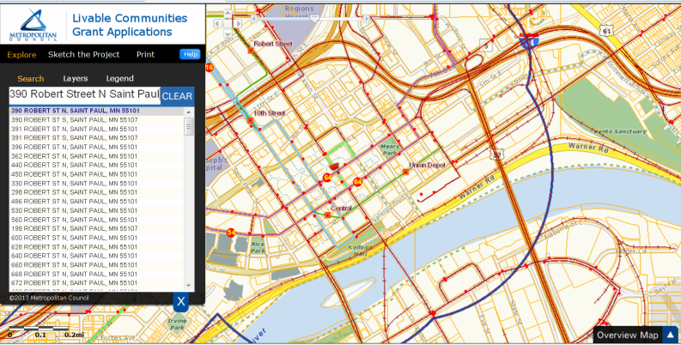
Click “Sketch the Project” and select the appropriate grant category, Tax Base Revitalization Account. Provide a name for your project. (This name will appear at the top of the map once the map is created.) | 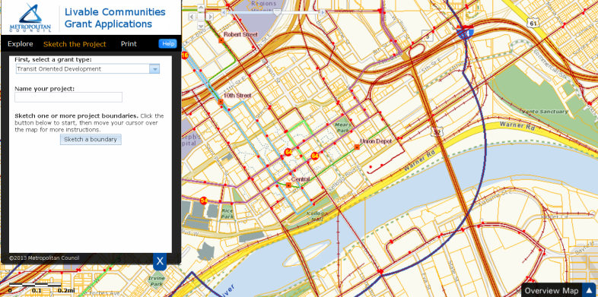
You may use the zoom and pan buttons to navigate to your project site. Click “Sketch a Boundary” and, using the crosshair as a guide, draw the project boundary. A gray polygon with a red outline will begin to appear. Once you have finished outlining the boundary, double click to close the polygon. If there are multiple, non-contiguous parcels that are part of your Project, you have the option of sketching another boundary. | 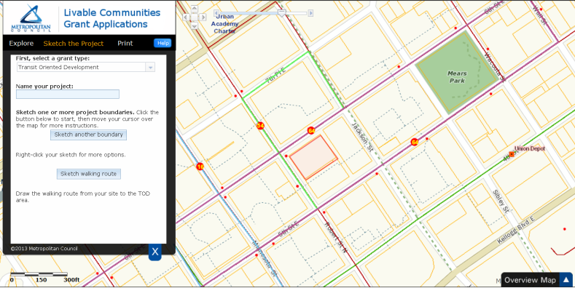
Select “Print” and “Create the maps”. The system will generate 3 maps:  - Parcel Map  - Aerial View Map  - Overview Map  (Please be patient – depending on your connection, it can take up to 1 minute to generate the maps.)  Click each PDF to download them separately. | 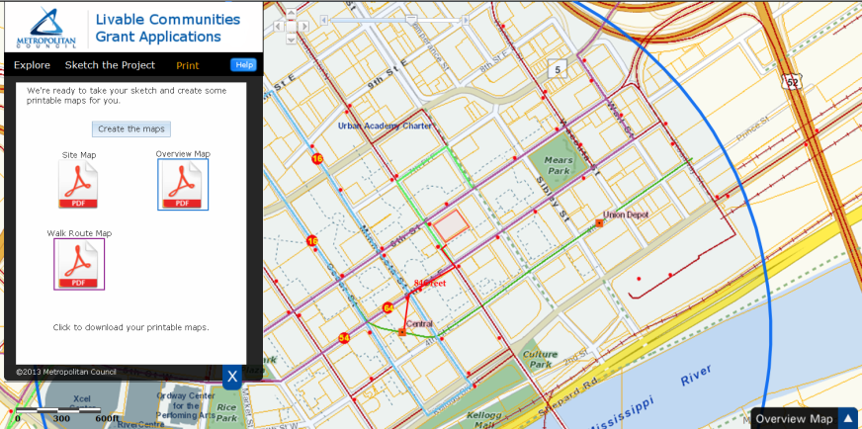

Attachment A –Examples of Environmental Budgets

SAMPLE CLEAN-UP BUDGET
Tax Base Revitalization Account - USES
I. INVESTIGATION AND CLEAN-UP |  | Total Cost | TBRA | DEED | County ERF | EPA | Private
A | SITE INVESTIGATION & REMEDIATION PLAN DEV.
 | 1. Phase I | $2,000 |  |  |  |  | $2,000
 | 2. Phase II | $60,000 |  |  |  | $40,000 | $20,000
 | 3. Preparation of RAP | $58,000 |  |  |  | $40,000 | $18,000
 | 4. Asbestos and Lead-based Paint Survey | $12,000 | 12,000
 | Total Site Investigation and RAP | $132,000 | $12,000 | $0 | $0 | $80,000 | $40,000
B | IMPLEMENTING THE PLAN: CLEANUP COSTS
 | 1. Soil handling costs
 | Mobilization | $20,000 | $10,000 | $10,000
 | Excavation of contaminated soils (8,000 CY @ $5/CY) | $40,000 | $8,000 | $20,000 | $4,000 |  | $8,000
 | Loading of contaminated soils (8,000 CY @ $3.50/CY) | $28,000 | $5,600 | $14,000 | $2,800 |  | $5,600
 | Transportation of contaminated soils (8,000 CY @ $13/CY) | $104,000 | $20,800 | $52,000 | $10,400 |  | $20,800
 | Disposal of contaminated soils (9,600 TONS @ $18/TON) | $172,800 | $34,560 | $86,400 | $17,280 |  | $34,560
 | Back-fill (8,000 CY @ $5/CY) | $40,000 | $8,000 | $20,000 | $4,000 |  | $8,000
 | Demobilization | $20,000 | $10,000 | $10,000
 | 2. Remove underground petroleum storage tank | $6,000 | $6,000
 | Petroleum-impacted soils (i.e. 100 CY. @ $7/CY) | $700 | $700
 | 3. Monitoring wells | $2,500 | $2,500
 | Closing out monitoring wells | $1,000 | $1,000
 | 4. Contract for on-site testing during clean-up | $15,000 | $5,000 | $10,000
 | 5. Contamination monitoring contract | $30,000 | $5,000 | $20,000 | $5,000
 | 6. Asbestos abatement (Include attached line item budget) | $77,800 | $77,800
 | 7. Lead-based paint abatement (Include attached line item budget) | $26,070 | $26,070
 | 8. Other hazardous materials disposal (not grant-eligible) | $12,000 |  |  |  |  | $12,000
 | 9. Mold removal (not grant-eligible) | $18,000 |  |  |  |  | $18,000
 | Total Cleanup Implementation | $613,870 | $221,030 | $242,400 | $43,480 | $0 | $106,960

I. CLEAN-UP Continued
C | UNIT COSTS FOR ASBESTOS ABATEMENT
 | Location | Suspect Material Description | Friable (F)/Non-Friable (NF) | Unit Quantity | Unit | Unit Costs | Price
 | Basement
 |  | 1 inch to 6-inch fibrous pipe insulation | F | 220 | LF | $20.00 | $4,400
 |  | 7- inch to 12-inch aircell pipe insulation | NF | 80 | LF | $22.00 | $1,760
 |  | 6-inch pipe fittings | NF | 9 | Each | $45.00 | $405
 |  | 12-inch pipe fittings | NF | 3 | Each | $45.00 | $135
 |  | Boiler door & gasket | F | 2 | Each | $25.00 | $50
 |  | Boiler drum | F | 32 | SF | $35.00 | $1,120
 |  | Electrical panel | NF | 1 | Each | $100.00 | $100
 | 1st Floor
 |  | 12x12 inch floor tile and mastic | NF | 4,200 | SF | $3.00 | $12,600
 |  | Wall Joint Compound | NF | 200 | SF | $2.00 | $400
 |  | Tan Window Caulk | NF | 1,500 | LF | $4.00 | $6,000
 |  | Sink undercoating | NF | 2 | Each | $65.00 | $130
 |  | Fire Doors | NF | 2 | Each | $200.00 | $400
 | 2nd Floor
 |  | 9x9 inch floor tile | NF | 1,600 | SF | $3.00 | $4,800
 |  | 12x12 inch ceiling tile & adhesive | F | 1,200 | SF | $8.00 | $9,600
 | 3rd Floor
 |  | Plaster | F | 1,200 | SF | $2.00 | $2,400
 |  | Floor tile mastic | NF | 6,000 | SF | $2.00 | $12,000
 |  | Grey vinyl baseboard | NF | 300 | LF | $1.50 | $450
 |  | 2 X 4 foot ceiling panels & adhesive | NF | 300 | SF | $4.00 | $1,200
 | Roof
 |  | Grey Caulking on Roof | NF | 500 | LF | $9.00 | $4,500
 |  | Black Flashing | NF | 500 | LF | $5.00 | $2,500
 | Abatement Mobilization/Demobilization |  |  |  |  |  | $625
 | Abatement Design Manual and Specifications (25 hours @$125.00/hr) |  |  |  |  |  | $3,125
 | Abatement Project Oversight (30 hours @ $95.00/hr) |  |  |  |  |  | $2,850
 | Asbestos Closeout Report (50 hours @ $125.00/hr) |  |  |  |  |  | $6,250
 | TOTAL |  |  |  |  |  | $77,800

I. CLEAN-UP Continued
D. | UNIT COSTS FOR LEAD-BASED PAINT ABATEMENT
 | Location | Abatement Method | Surface Area
 |  |  | Walls | Columns | Walls (Stairwell) | Rails (Stairwell) | Other | Total LBP- Surface Area | Unit Cost | Unit | Abatement Cost
 | Basement
 |  | Stabilize & encapsulate | 800 SF | 400 SF | 75 SF |  |  | 1,275 SF | $2.00 | SF | $2,550.00
 |  | Stabilize & encapsulate |  |  |  | 60 LF |  | 60 LF | $2.25 | LF | $135.00
 | 1st Floor
 |  | Removal | 800 SF | 400 SF | 75 SF |  |  | 1,275 SF | $4.00 | SF | $5,100.00
 |  | Removal |  |  |  | 60 LF |  | 60 LF | $2.25 | LF | $135.00
 |  | Removal |  |  |  |  | 8 windows | -- | $90.00 | Each | $720.00
 | 2nd Floor
 |  | Removal | 800 SF | 400 SF | 75 SF |  |  | 1,275 SF | $4.00 | SF | $5,100.00
 |  | Removal |  |  |  | 60 LF |  | 60 LF | $2.25 | LF | $135.00
 |  | Removal |  |  |  |  | 12 windows | -- | $90.00 | Each | $1,080.00
 | 3rd Floor
 |  | Removal | 800 SF | 400 SF | 75 SF |  |  | 1,275 SF | $4.00 | SF | $5,100.00
 |  | Removal |  |  |  | 60 LF |  | 60 LF | $2.25 | LF | $135.00
 |  | Removal |  |  |  |  | 12 windows | -- | $90.00 | Each | $1,080
 | West Exterior Advertising) | Stabilize & encapsulate | 300 SF |  |  |  |  | 300 SF | $16.00 | SF | $4,800.00
 | TOTAL |  | 3,500 SF | 1,600 SF | 300 SF | 240 LF | 32 windows |  |  |  | $26,070.00

II. DEVELOPMENT/REDEVELOPMENT BUDGET
 |  | Total Cont. | TBRA | DEED | County ERF | EPA | Private
A | Acquisition | $850,000
B | Demolition of dilapidated building (eligible DEED project cost) | $165,000 |  | $165,000
C | Site preparation (not including cleanup) | $315,000 |  |  |  |  | $315,000
D | Soft Costs (i.e., A&E, etc.) | $500,000 |  |  |  |  | $500,000
E | Construction: 52,000 ft office showroom | $2,100,000 |  |  |  |  | $2,100,000
F | Infrastructure: road resurface and utilities | $890,000 |  |  |  |  | $890,000
 | Total Development/Redevelopment Budget | $4,820,000 |  | $165,000 |  |  | $3,805,000
G | Environmental (Grants, grant match and unmatched grant costs and ineligible environmental costs in Investigation and Cleanup in Uses Table I above) | $745,870 | $233,030 | $407,400 | $43,480 | $80,000 | $146,960
 | TOTAL DEVELOPMENT COST | $5,565,870
 | Total Development Cost per SF | $107.04

SAMPLE SITE INVESTIGATION & REMEDIATION PLAN DEVELOPMENT BUDGET
Tax Base Revitalization Account
PROPOSED PROJECT BUDGET FOR BLOCK "Z" SITE
___City____, MN
I. USES
A. Phase I environmental site assessment (Complete, March) $2,500
B. Hazardous Materials Survey* (0% Complete) $3,000
C. Phase II environmental site assessment* (0% Complete) $35,000
mobilization/demobilization $
# of soil samples $
# ground water samples $
# soil vapor samples $
# of test pits $
# total field hours at $_/hour $
equipment/supplies $
report preparation $
D. Preparation of RAP* (0% Complete) $18,000
E. MPCA _hours at $125/hour $
Total $58,500
II. SOURCES
A. TBRA (75 % of eligible project budget)/ Pending [Date] $42,000
B. Property Owner (previously incurred costs) $2,500
C. Developer (25% match) $14,000
Total $58,500

Attachment B - SAMPLE CITY RESOLUTION - Tax Base Revitalization Account
RESOLUTION NO. __________
CITY OF __________, MINNESOTA

AUTHORIZING APPLICATION FOR THE TAX BASE REVITALIZATION ACCOUNT

WHEREAS the City of __________ is a participant in the Livable Communities Act's Local Housing Incentives Account Program for 2015 as determined by the Metropolitan Council, and is therefore eligible to make application apply for funds under the Tax Base Revitalization Account; and
WHEREAS the City has identified a contamination cleanup project within the City that meet the Tax Base Revitalization Account’s purposes and criteria and are consistent with and promote the purposes of the Metropolitan Livable Communities Act and the policies of the Metropolitan Council’s adopted metropolitan development guide; and
WHEREAS the City has the institutional, managerial and financial capability to ensure adequate project and grant administration; and
WHEREAS the City certifies that it will comply with all applicable laws and regulations as stated in the contract grant agreements; and
WHEREAS the City finds that the required environmental assessment or contamination cleanup will not occur through private or other public investment within the reasonably foreseeable future without Tax Base Revitalization Account grant funding; and
WHEREAS the City represents that it has undertaken reasonable and good faith efforts to procure funding for the activities for which Livable Communities Act Tax Base Revitalization Account funding is sought but was not able to find or secure from other sources funding that is necessary for cleanup completion and states that this representation is based on the following reasons and supporting facts:

BE IT FURTHER RESOLVED that, the City Council of ______________ authorizes __________ to submit an application for Metropolitan Council Tax Base Revitalization Account grant funds and, if the City is awarded a Tax Base Revitalization Account grant for this project, the City will be the grantee and agrees to act as legal sponsor to administer and be responsible for grant funds expended for the project contained in the Tax Base Revitalization grant application submitted on November 2, 2015.

_______________________ _______________________
Mayor Clerk

Attachment C - Application Checklist
Applications are due by 5:00 PM on November 2, 2015. All forms and attachments must be submitted using WebGrants. (The attachments should recognize text (either through a file conversion or use of optical character recognition (OCR)) and allow text searches.)

TBRA Pilot Application Contents:
2015 TBRA Pilot Form (WebGrants Online Form)
Application Attachments
Resolution from applicant (Sample in Appendix B) authorizing TBRA application submission (PDF). Name the file “TBRA Resolution – [Project Name].”
Legal Description of Site (PDF). Name the file “TBRA Legal Descrip – [Project Name].”
Maps (include project boundary)
Parcel Map using LCA Make-a-Map – a street map showing parcels and parcel identification numbers (including a county ID) for the redevelopment site. (PDF)
Aerial Map using LCA Make-a-Map – An aerial map showing the redevelopment project boundary. (PDF)
Overview Map using LCA Make-a-Map – An aerial map showing ¼ mile and ½ mile radius from the project site. (PDF)
Planned Land Use Map(s) from city comprehensive plan and adopted local area plans, if applicable, showing redevelopment project boundaries. Name the file “TBRA PLU Map – [Project Name].”
Project Images and Figures
Current Conditions (Include image(s) of building interiors for abatement requests.) Name the file “TBRA Current Images – [Project Name].”
Proposed Soil Excavation Location with Estimated Volume (for soil cleanup grant requests). Name the file “TBRA Proposed Excavation– [Project Name].”
Map of the buildable area with set backs, easements, etc. Name the file “TBRA Buildable Area – [Project Name].” Environmental Reports
RAP (PDF) Name the file “TBRA RAP– [Project Name].”and/or
Phase II Environmental Site Assessment (PDF) Name the file “TBRA Phase II ESA – [Project Name].” (Submit if analytical tables not included in RAP)
Phase I Environmental Site Assessment (PDF) Name the file “TBRA Phase I ESA – [Project Name].” (Submit if analytical tables not included in RAP)
Hazardous Materials Report (PDF) for asbestos or lead-based paint
Response Action Plan Approval from PCA (PDF) for soil or ground water cleanups. Name the file “TBRA RAP Approval – [Project Name].”
Budgets (Excel spreadsheet)
Detailed Contamination Cleanup Budget
Line-item Budget for Asbestos and Lead-Based Paint
Response for Proposals (Demonstrating preferred development guidelines)

Attachment D: Selected Brownfield Resources:
Brownfields Resource Guide: http://mn.gov/deed/images/Brownfields_Resource_Guide.pdf
Dakota County, Redeveloping Brownfields: http://www.co.dakota.mn.us/Environment/ContaminatedSites/RedevelopingBrownfields/Pages/default.aspx
Hennepin County Environmental Response Fund: http://www.hennepin.us/business/property/environmental-response-fund
Metropolitan Council, Tax Base Revitalization Account: http://www.metrocouncil.org/Communities/Services/Livable-Communities-Grants/Tax-Base-Revitalization-Account-(TBRA).aspx?source=child
Ramsey County Environmental Response Fund: http://www.co.ramsey.mn.us/ced/environ_response_fund.htm
Minnesota Department of Employment & Economic Development, Contamination Cleanup & Investigation Program: http://mn.gov/deed/government/financial-assistance/cleanup/contamination.jsp
Minnesota Pollution Control Agency, Cleanup of Contaminated Sites: http://www.pca.state.mn.us/index.php/waste/waste-and-cleanup/cleanup/cleanup-of-contaminated-sites.html
U.S. Environmental Protection Agency, Brownfields: http://epa.gov/brownfields/
Minnesota Brownfields: http://www.mnbrownfields.org/
Minnesota Lead Contractors and Consultants: http://www.health.state.mn.us/divs/eh/lead/find_firm/pb_firms_by_state.cfr?state_code=MN
Minnesota Asbestos Contractors and Consultants: http://www.health.state.mn.us/divs/eh/asbestos/find_contractor/asbestos_contractor_report.cfr?region_code=ME
Other Service Providers: http://www.mntap.umn.edu/potw/resources/16-WaterConsult.pdf, http://mnbrownfields.org/land-recycling-101/directory-of-service-providers/
(Brownfield resources are provided for educational purposes. The Metropolitan Council does endorse individual organizations, firms or programs.)

