METROPOLITAN COUNCIL LIVABLE COMMUNITIES

TAX BASE REVITALIZATION ACCOUNT
CONTAMINATION CLEANUP GRANT APPLICATION GUIDE
2015
Cleanup Grant Application Guide Topics ii
What is the purpose of Tax Base Revitalization (TBRA) grants? ii
ELIGIBLE APPLICANTS and QUALIFYING SITES ii
Who is eligible to apply for a TBRA grant? ii
What type of redevelopment sites are eligible to compete for a grant? iii
ELIGIBLE and INELIGIBLE USE OF GRANT FUNDS iv
Quality of Cleanup Plans v
Additional Factors Affecting Cost Eligibility v
When can I incur costs to be paid using grant funding? vi
Cleanup Grant Timeline vi
How to Request Funding for Cleanup Costs Already Incurred vii
Other Requirements viii
Matching funds viii
Affordable Housing ix
Residential Marketing Plans ix
AWARDING GRANTS/COMPETITIVE PROCESS ix
Funding Limits xii
LOCAL SUPPORT xii
REPORTING REQUIREMENTS xii
PROCEDURES and PERMISSIONS xii
How do I apply? xii
Use of Application Images xiii
Appendices and Attachments xiv
Appendix A: Enabling Legislation and Requirements for Participating Cities: xiv
Appendix B: Using WebGrants Online Application Forms xv
Appendix C: Using Make-a-Map xvi
Attachment A – SAMPLE CLEAN-UP BUDGET A
Attachment B - SAMPLE CITY RESOLUTION - Tax Base Revitalization Account B
Attachment C - Application Checklist C
Attachment D: Selected Brownfield Resources: D

Cleanup Grant Application Guide Topics
This document provides information for applicants and grant writers on
- eligible applicants
- eligible communities and sites,
- eligible and ineligible uses for grant funds
- activities or use of grant funds
- the competitive project selection process including expected redevelopment outcomes
- grant terms and
- reporting and grant administration compliance requirements.
Additional reference information and suggestions are also provided in appendices including
- use of the online mapping tool
- use of the WebGrants online application system
- sample contamination cleanup budget
- sample public resolution of support
- checklist of required application contents.

What is the purpose of TBRA grants?
TBRA funding helps make areas that have lost commercial/industrial activity available for economic redevelopment. The grants provide funds for environmental site investigation and cleanup for redevelopments that enhance the city tax base, promote job retention or job growth and/or create or preserve affordable housing.
Cleanup grants are intended for applicants with projects that have recently completed their environmental site investigation and are seeking public funding to assist with the cost of implementing a cleanup plan for eligible activities and beginning construction on a specific redevelopment project.

ELIGIBLE APPLICANTS and QUALIFYING SITES

Who is eligible to apply for a TBRA grant?
By state statute, applicants must be a local governmental unit, which may be a:
- Municipality (a statutory or home rule charter city or township) currently participating in the Metropolitan Livable Communities Housing Incentives Program
- Metropolitan county
- Housing and Redevelopment Authority, Economic Development Authority, Community Development Authority or Port Authority
Redevelopment projects proposed by applicants in categories (B) and (C) must be located in participating municipalities.
Individuals and/or private or nonprofit developers are not eligible to apply. However, project sites are typically privately owned. Other interested groups such as property owners or private or not-for profit developers must find a public applicant to submit an application on their behalf.

What type of redevelopment sites are eligible to compete for a grant?
Eligible Sites | Ineligible Sites
- Properties with contamination that exceeds safe standards set by the Minnesota Pollution Control Agency (MPCA), Minnesota Department of Agriculture (MDA) or the Minnesota Department of Health (MDH) for the intended use.  - Properties that are publicly-owned OR privately-owned that will  - increase the tax base AND  - add or preserve jobs AND/OR  - add or preserve affordable housing  after redevelopment is completed.  - Total cleanup costs are over 1% of the total development cost | A private responsible party has been identified and is likely financially capable of carrying out the cleanup in the foreseeable future;  TBRA funding is not needed in order for the redevelopment to proceed;  Eligible cleanup costs are equal to one percent or less than the total project development costs;  Redevelopment proposals that will not generate property taxes or payments in lieu of taxes (PILOT/PLT);  - The application does not score at least 50% (75 points) of the total possible points (150 points)
Contamination cleanup applications may be determined ineligible for funding if:
adequate cleanup funding is available from other public and private sources;
any part of a redevelopment site that will be funded by the Federal Superfund Program in the current or following fiscal year
the redevelopment requires extensive new regional infrastructure beyond that which is already planned
the redevelopment is not consistent with the redevelopment component of the municipality's comprehensive plan (Minn. Stat. §473.859, Subd. 5).

ELIGIBLE and INELIGIBLE USE OF GRANT FUNDS
TBRA funding can help pay the cost difference between building on a contaminated site and building on a clean site. TBRA funding can also help pay the environmental costs of adaptive reuse of an existing or obsolete structure that requires the removal or added maintenance of hazardous building materials.
Eligible Costs | Ineligible Costs
- recently completed site investigation activities*  - Phase I environmental site assessment  - Phase II environmental site assessment work plans  - Phase II environmental site assessment  - Hazardous building materials assessment  - Development of a Response Action Plan  - Abatement plans  - Asbestos emissions control plans (ECP)  - contaminated soil remediation**,  - groundwater remediation**,  - soil vapor mitigation**,  - hazardous building materials abatement or mitigation (asbestos and/or lead-based paint only) *** including  - Abatement area containment  - Implementing asbestos emissions control plan  - Asbestos removal or encapsulation  - Lead-based paint removal or stabilization  - Loading, transport and disposal of asbestos and/or lead-based paint wastes  - limited demolition (as necessary to access contamination ONLY)  - environmental oversight | - “soft costs” such as  - administrative overhead,  - travel expenses,  - legal fees,  - bonds,  - insurance,  - permits,  - licenses or authorization fees,  - costs associated with preparing grant proposals or applications or bids,  - applicant project coordination costs, operating expenses, planning costs, and prorated lease and salary costs.  - non-hazardous wastes, such as household waste, construction debris and solid waste (e.g., old tires)  - regulated materials found in buildings, such as mercury in thermostats, oils in door closers, and other issues related to heating, ventilation and air conditioning systems  - geotechnical costs  - managing excess clean soil  - construction costs  - costs for work outside of the redevelopment site (as identified in the application & cleanup plan)
* The costs for the investigation work incurred included in a contamination cleanup grant request will only be reimbursed if the TBRA applicant’s overall project is recommended for funding.
** Costs must be for activities included in a Response Action Plan (RAP) - and amendments, if any - approved by the MPCA or MDA for the redevelopment being proposed. (Projects working with the Voluntary Investigation Cleanup (VIC) Program and/or the Petroleum Brownfields Program (PBP) should start early. The MPCA requires a minimum of 30 working days before the TBRA application deadline to respond to a request for approval in time to apply for a grant.)
*** Costs associated with asbestos and lead-based paint abatement must be for activities that meet state standards established by the Minnesota Department of Health and Minnesota Occupational Safety and Health Administration (OSHA) as well as federal standards including Asbestos Hazard Emergency Response Act (AHERA) and the Toxic Substances Control Act (TSCA) and the Environmental Protection Agency’s Renovation, Repair and Painting Rule.

Quality of Cleanup Plans
For soil and/or ground water or vapor intrusion contamination, it is required that applicants have a RAP approved by the MPCA. It is recommended that applicants start working with the Voluntary Investigation Cleanup Program and/or the Petroleum Brownfields Program (PBP) early and that they submit the reports by those programs to the MPCA a minimum of 30 working days prior to the TBRA application deadline. (The MPCA requires this lead time to assure a review of a RAP.) For projects with RAPs that do not include tables of the soil, ground water and/or soil vapor sampling results, applicants must also submit a Phase II environmental site assessment (ESA) as an attachment.
Applicants that are applying for asbestos or lead-based paint cleanup must submit an assessment report that meets standards set by the Minnesota Department of Health identifying asbestos or lead-based paint content of the building material (e.g., percentage), the quantities of materials to be abated, condition of the materials assessed and include maps of sampling locations and laboratory analysis results.

Additional Factors Affecting Cost Eligibility
We will consider the following additional factors when reviewing costs to be paid using grant funds.
Eligible activities for contaminated soil remediation include excavation, transportation, disposal fees for removal of contaminated soil conducted according to the RAP submitted with the application.
However, unregulated fill soil – excess soil that has contamination at concentrations less than the MPCA’s most conservative risk-based values – is eligible for reimbursement of disposal and transportation costs only. (The standard costs for excavating and loading of unregulated fill soil are not eligible.)
The costs for replacing contaminated fill with clean back fill and grading of clean soil are eligible as long as the volume of clean soil added matches the volume of contaminated soil removed.
In order to minimize the amount of funds needed to replace contaminated soils, applicants are encouraged to design and implement projects in a way that minimizes the amount of backfill needed to replace the contaminated soils (e.g. underground parking, basements). Any underground use must be consistent with the approved RAP.
Costs associated with soil vapor mitigation must be based on data provided that shows soil vapors are over 10 times the MPCA intrusion screening value thresholds.
Actions documenting environmental monitoring systems or the successful implementation of a RAP such as technical writing are eligible for reimbursement.
We recommend applicants use separate line items when bidding work to be paid by grants to simplify the review of reimbursement requests if a grant is awarded.
Contractor markups for subcontractor costs are eligible but limited to 10% or less.

When can I incur costs to be paid using grant funding?
To be eligible for grants, all eligible cleanup activities must occur after the grant award date but before the grant term ends (three years).

Cleanup Grant Timeline
End of grant term
Planning
Occupancy
Construction
Site investigation
Cleanup
After date of award
No more than 180 days prior to grant application due date

Exceptions
- Costs included in a cleanup grant request may include reimbursement for site investigation activities incurred up to 180 days before the date of application.
- Supplemental TBRA grants may include cleanup work performed up to 180 days prior to the grant application due date with a written eligibility determination from Metropolitan Council staff.

How to Request Funding for Cleanup Costs Already Incurred
In limited situations, funding may be requested for cleanup work that has been completed before a grant application date (e.g., May 1 or November 1) or before the Metropolitan Council awards a grant. A written eligibility determination request from Metropolitan Council staff is required before supplemental work begins to include costs for any cleanup that occurred before a grant application submission deadline in a grant request. (Recent investigation work already completed does not require special permission.)
For each cost to be eligible for grants, the work must meet all the following conditions:
Yes, completed work is eligible for a grant request | No, completed work is not eligible for a grant request
- Project site has an active cleanup grant from the Metropolitan Council | - Project site does not have an active cleanup grant from the Metropolitan Council
- Cost is a cleanup activity | - Cost is not a cleanup activity
- Cost was for soil or ground water remedial activity or a soil vapor mitigation activity in an approved cleanup plan in use at the time the work occurred OR  - Cost was for an abatement activity in an abatement plan written by an individual licensed by MDH | - Cost was for soil or ground water remedial activity or a soil vapor mitigation activity but was not in an approved cleanup plan at the time the work occurred OR  - Cost was for an abatement activity but was not in an abatement plan written by an individual licensed by MDH
- Cost occurred after a cleanup plan (or revision) was approved or the abatement plan was completed. | - Cost occurred before a cleanup plan (or revision) was approved or the abatement plan was complete.
- Activity occurred 180 days or less before TBRA application due date | - Activity occurred over 180 days before the TBRA application due date
- Provided a written eligibility request to Metropolitan Council staff before the cleanup activities start that  - describes the cleanup work and when the work will start  - explains why the work must start before the application date  - identifies the date the cleanup plans were approved  - includes a statement acknowledging that the applicant understands that while the request may make the work eligible for future funding, it does not commit the Council to funding the project. | - Did not submit a complete written eligibility request to Metropolitan Council staff before activities requested started.

Other Requirements

Matching funds
The need for matching funds depends on the type of sources requested for cleanup funding.
- There is no matching fund requirement if 100% of the eligible cleanup cost will be requested using TBRA contamination cleanup grants. (This option is often true for projects requesting funding for abatement activities only.)
- If DEED and TBRA funding will be requested for projects with the seven-county metropolitan area, TBRA funds may be requested to provide up to 13% (or more) of the total eligible project cleanup costs as part of the 25% local match for cleanup costs required in DEED's Contamination Cleanup Grant Program.
- If DEED, TBRA, and Ramsey County or Hennepin County ERF funding will be requested, TBRA funds and county funds used may be used as part of the minimum required match for grants from DEED.
- Not all TBRA costs (e.g., abatement) will be eligible for use as matching funds to meet DEED’s requirement. In this case, the TBRA request may include cleanup activities that will not be used matched funds for DEED.

Affordable Housing
For 2015 affordable housing is defined as ownership or rental housing affordable to households earning 80% of the area median income (AMI) or less. Units must be affordable for 15 years or more.
Projects will be evaluated on the amount of affordable housing relative to the amount of TBRA funding requested for the project. A minimum of 20% of the total housing units proposed must be affordable for a project to be considered for affordable housing points.
Residential units considered affordable for applications submitted in 2015 include any units
- for sale at $240,500 or less OR
- for rent based on the number of bedrooms including tenant-paid utilities
2015 RENTAL HOUSING
Bedroom size: | Monthly gross rent including tenant-paid utilities, affordable at 30% of AMI | Monthly gross rent including tenant-paid utilities, affordable at  50% of AMI | Monthly gross rent including tenant-paid utilities, affordable at  60% of AMI | Monthly gross rent including tenant-paid utilities, affordable at 80% of AMI
Efficiency | $455 | $758 | $910 | $1,212
1 bedroom | $487 | $812 | $975 | $1,299
2 bedrooms | $585 | $975 | $1,170 | $1,560
3 bedrooms | $675 | $1,126 | $1,351 | $1,801
4 bedrooms | $753 | $1,256 | $1,507 | $2,009

Residential Marketing Plans
All proposed redevelopments that include housing – market-rate or affordable – must have an affirmative fair housing marketing plan in place before offering the units for rent or for sale. See the following example of typical considerations to include in a marketing plan: Minnesota Housing Sample Affirmative Fair Housing Marketing Plan

AWARDING GRANTS/COMPETITIVE PROCESS
The Metropolitan Council will consider how well a proposed project will meet statutory requirements and regional development goals described in the Thrive MSP 2040 plan when awarding grants. Council staff will consult with external partners, including DEED, Hennepin and Ramsey County, the MPCA, and others when evaluating applications.
The Council will rank cleanup applications according to the extent they demonstrate the following:
Cleanup |  | Possible Points
Increase to the tax base | 25
- Increase the tax base of the recipient municipality.
- Add tax revenue in the near term. (Projects not in or not expected to be in a Tax Increment Finance district earn five points because all the affected tax jurisdictions benefit immediately.)
Access to Jobs and/or affordable housing and economic competitiveness | 25
- Increase or retain the number of permanent jobs in the region;
- Preserve and/or increase the number of permanent living wage jobs in the region;
- Increase permanent living wage jobs within and near areas of concentrated poverty;
- Construction of distribution facilities and commercial-industrial space for freight-generating industries near regional intermodal freight terminals.
- Add affordable rental or ownership housing units.
OR
- Preserve existing affordable housing if
- the building undergoes substantial rehabilitation:
- doing so ensures the extension of long-term affordability with income restrictions on tenants AND
- includes federal subsidy (e.g., Section 8) as part of the redevelopment financing.
(A minimum of 20% of the total housing units proposed must be affordable for a project to be considered for affordable housing points, and the minimum term of affordability is 15 years.)
Brownfield cleanup/environmental health improvements | 25
Clean-up of the most contaminated sites to provide the greatest improvement in the environment and the greatest reduction in human health risk.
Orderly and efficient land use | 35
Show how the cleanup and redevelopment project supports Thrive MSP 2040 goals by:
- Supporting growth in the region and around regional transit through adaptive reuse, infill development or redevelopment to make the best use of public and private investment.
- Accommodating growth through increased redevelopment density.
- Providing or preserving housing choices to give people in all life stages and of all economic means viable choices for safe, stable and affordable homes.
- Conserving vital regional natural resources features and functions.
- Conserving, restoring or protecting the region’s water resources through environmentally sound opportunities for recharging groundwater with best management practices for stormwater.
- Providing access to regional parks and trails and transit network using a variety of modes of travel.
- Showing consistency of proposed use with regional highway system and investments in the regional transit system and showing potential for growth in transit service
Readiness and market demand | 25
- Demonstrate readiness to proceed with project site cleanup.
- Demonstrate market demand for proposed redevelopment elements in the project area and demonstrate readiness to promptly implement the proposed project if/when TBRA funding is provided, including identifying an end-stage developer and commitments by occupants.
Partnership | 5
Represent innovative partnerships among various levels of government and private for-profit and nonprofit sectors.
Community’s Housing Performance Score | 10
The applicant’s Housing Performance Score will be converted from a 100 point scale to a 10 point scale.
If a proposed project includes new affordable housing or if affordable housing is located within the project site/area, the proposal will be held harmless by assigning the higher of the community’s actual score or the average score for this section from all proposals.
TOTAL | 150
Applications must score 75 points or more out of 150 points
to be considered for funding.
Redevelopment and preservation projects are expected to spend TBRA grants on cleanup and start construction before the three-year grant term ends.

Funding Limits
If requests for grants exceed the available funds for an application cycle,
- no more than one-half of the funds may be granted to projects in a single city and
- no more than three-quarters of the funds may be granted to projects located in Minneapolis and St. Paul.
There are no limits on the number of TBRA applications submitted.

LOCAL SUPPORT
Any application for funds under this program must include a resolution supporting the application from the local unit of government within which the proposed project is located. The resolution must confirm that the project would not occur through private or other public investment without Council funding.
Municipalities occasionally partner with counties or other agencies (e.g., a county, housing or development/redevelopment authorities; collectively, “Partners”) when preparing application for funds; however, only one eligible entity may be cited as the applicant. If the application is successful that applicant will become the grantee.

REPORTING REQUIREMENTS
Recipients of Tax Base Revitalization Account grants must submit progress and annual reports. Semiannual progress reports are required during the grant term for active grants. Additional annual reports are required in the spring after the termination of the grant period and three years annually thereafter to the Metropolitan Council. Annual reporting includes:
the site cleanup and/or development activities completed in the previous calendar year,
the amount of net tax capacity and the total property taxes paid on this parcel(s) (land and buildings) for the preceding year, and
the number of full-time equivalent jobs (FTEs) including both part-time and full-time jobs on the site at the end of the previous year, and the number of the FTEs that are at or above living-wage level.

PROCEDURES and PERMISSIONS

How do I apply?
An online WebGrants application information and attachments must be submitted by the grant application deadline (November 2, 2015) by 5:00 PM.
Attachments submitted with a completed application form should recognize text (either through a file conversion or use of optical character recognition (OCR)), allow text searches and include bookmarks to each of the application sections and application attachments.
The application form is available online at
http://www.metrocouncil.org/Communities/Services/Livable-Communities-Grants/WebGrants-Info.aspx?source=child.
- Select the WebGrants link under the heading ‘Using WebGrants’ to log in. (More information on using WebGrants is provided below.)
- Next, select the link to the funding opportunity with the title ‘2015 TBRA Cleanup Fall Round’.
Contact the TBRA coordinator at 651-602-1054 if you have questions.
This Notice of Funding Availability is subject to applicable federal, state, and municipal laws, rules and regulations. The Metropolitan Council reserves the right to modify or withdraw this RFP at any time.

Use of Application Images
By submitting any renderings, images, perspectives, sections, diagrams, photos or other copyrightable materials (collectively, “copyrightable materials”) with an application, you certify that your organization is the owner of the copyrightable materials or is fully authorized to grant permissions regarding the copyrightable materials and that the copyrightable materials do not infringe upon the copyrights of others.
Your organization also agrees that:
- the Council has a nonexclusive royalty-free license and all necessary permissions to reproduce and publish any copyrightable materials for noncommercial purposes, including but not limited to press releases, presentations, reports, and on the internet; and
- your organization will not hold the Council responsible for the unauthorized use of the copyrightable materials by third parties. If your organization desires attribution on the copyrightable materials, you may include a discreet transparent watermark.

Appendices and Attachments

Appendix A: Enabling Legislation and Requirements for Participating Cities:
The Livable Communities Act (MN Statutes Chapter 473.25) created a voluntary, incentive-based approach to address the metropolitan area’s affordable and lifecycle housing issues and to help communities grow and succeed. It established the Metropolitan Livable Communities Fund, including three ongoing accounts from which eligible communities may apply for funding:
- The Tax Base Revitalization Account (TBRA) helps cities clean up contaminated urban land and buildings for subsequent redevelopment that could include commercial, industrial or housing opportunities. Restoring the tax base, developing more jobs near existing housing and services, and adding affordable housing to the region are primary objectives of this account
- The Livable Communities Demonstration Account (LCDA) awards grants to cities for development and redevelopment projects that achieve connected development patterns linking housing, jobs and services and maximizing the development potential of existing or planned infrastructure and regional facilities.
- The Local Housing Incentives Account (LHIA) helps preserve and expand lifecycle and affordable rental and ownership housing in the metropolitan area.
A fourth account, the Inclusionary Housing Account (IHA), operated during 1999-2000 with a single appropriation to support affordable housing developments in which the reduction of local controls and regulations resulted in reduced development costs.
To be able to request grant funding, communities choose to participate by:
- negotiating long-term affordable and lifecycle housing goals with the Council;
- adopting an LCA Housing Action Plan to identify and give direction to the city’s use of programs, official controls and fiscal devices to help accomplish these negotiated goals; and
- contributing to affordable housing activities at least the minimum annual amount required by a formula provided in the law. The formula is based on each community’s share of the tax levy supporting the Livable Communities Demonstration Account and determines an Affordable and Lifecycle Housing Opportunities Amount (ALHOA) specific to each community.
A list of communities participating in the Livable Communities Act program may be found at http://www.metrocouncil.org/Communities/Services/Livable-Communities-Grants/Communities-Participating-in-the-Livable-Communiti.aspx?source=child

Appendix B: Using WebGrants Online Application Forms
For information on using WebGrants see the WebGrants Manual located at http://www.metrocouncil.org/Communities/Services/Livable-Communities-Grants/Maps,-forms-misc/Using-the-Council-s-Online-Grant-Application.aspx.
Information is provided on
- registration
- security
- selecting a funding opportunity
- the user interface
and other topics to help you get started and familiarize you with using the online form.

Appendix C: Using Make-a-Map
A customized mapping tool has been created for applying for LCA Grants. To access Make-a-Map, follow this link:
http://giswebsite.metc.state.mn.us/publicmaps/lca

Follow the steps below to define your project boundary to save and print the required maps using the LCA Make-a-Map tool. For more detailed instructions, click the blue “help” button
Enter an address or landmark in the search bar to navigate to your project area. | 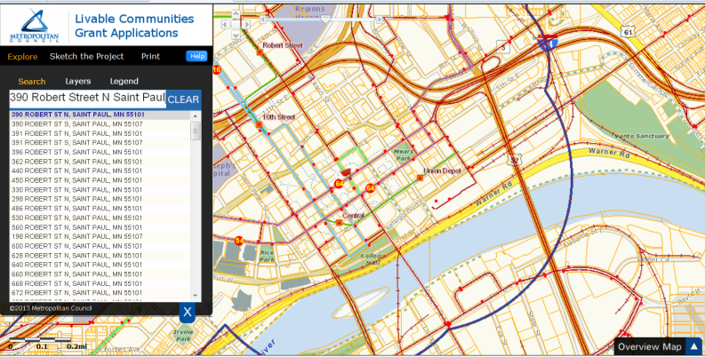
Click “Sketch the Project” and select the appropriate grant category, Tax Base Revitalization Account. Provide a name for your project. (This name will appear at the top of the map once the map is created.) | 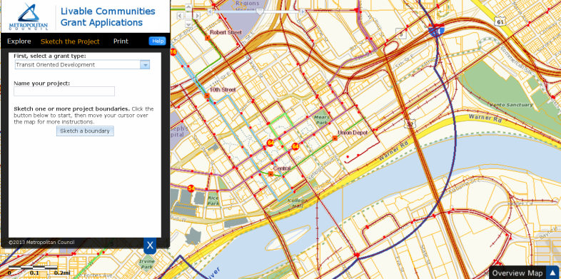
You may use the zoom and pan buttons to navigate to your project site. Click “Sketch a Boundary” and, using the crosshair as a guide, draw the project boundary. A gray polygon with a red outline will begin to appear. Once you have finished outlining the boundary, double click to close the polygon. If there are multiple, non-contiguous parcels that are part of your Project, you have the option of sketching another boundary. | 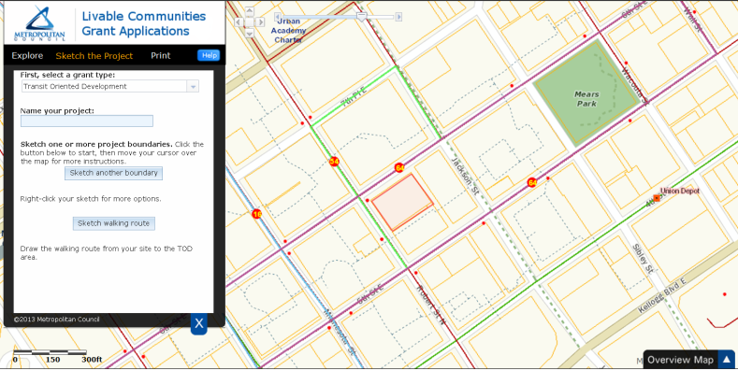
Select “Print” and “Create the maps”. The system will generate 3 maps:  - Parcel Map  - Aerial View Map  - Overview Map  (Please be patient – depending on your connection, it can take up to 1 minute to generate the maps.)  Click each PDF to download them separately. | 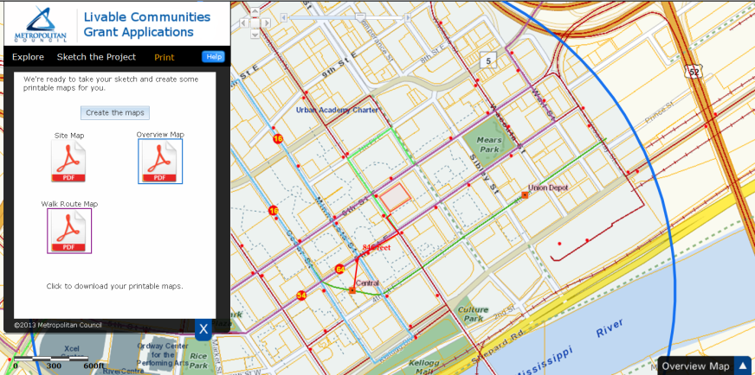

Attachment A – SAMPLE CLEAN-UP BUDGET
Tax Base Revitalization Account
USES
I. INVESTIGATION AND CLEAN-UP |  | Total Cost | TBRA | DEED | County ERF | EPA | Private
A | SITE INVESTIGATION & REMEDIATION PLAN DEV.
 | 1. Phase I | $2,000 |  |  |  |  | $2,000
 | 2. Phase II | $60,000 |  |  |  | $40,000 | $20,000
 | 3. Preparation of RAP | $58,000 |  |  |  | $40,000 | $18,000
 | 4. Asbestos and Lead-based Paint Survey | $12,000 | 12,000
 | Total Site Investigation and RAP | $132,000 | $12,000 | $0 | $0 | $80,000 | $40,000
B | IMPLEMENTING THE PLAN: CLEANUP COSTS
 | 1. Soil handling costs
 | Mobilization | $20,000 | $10,000 | $10,000
 | Excavation of contaminated soils (8,000 CY @ $5/CY) | $40,000 | $8,000 | $20,000 | $4,000 |  | $8,000
 | Loading of contaminated soils (8,000 CY @ $3.50/CY) | $28,000 | $5,600 | $14,000 | $2,800 |  | $5,600
 | Transportation of contaminated soils (8,000 CY @ $13/CY) | $104,000 | $20,800 | $52,000 | $10,400 |  | $20,800
 | Disposal of contaminated soils (9,600 TONS @ $18/TON) | $172,800 | $34,560 | $86,400 | $17,280 |  | $34,560
 | Back-fill (8,000 CY @ $5/CY) | $40,000 | $8,000 | $20,000 | $4,000 |  | $8,000
 | Demobilization | $20,000 | $10,000 | $10,000
 | 2. Remove underground petroleum storage tank | $6,000 | $6,000
 | Petroleum-impacted soils (i.e. 100 CY. @ $7/CY) | $700 | $700
 | 3. Monitoring wells | $2,500 | $2,500
 | Closing out monitoring wells | $1,000 | $1,000
 | 4. Contract for on-site testing during clean-up | $15,000 | $5,000 | $10,000
 | 5. Contamination monitoring contract | $30,000 | $5,000 | $20,000 | $5,000
 | 6. Asbestos abatement (Include attached line item budget) | $77,800 | $77,800
 | 7. Lead-based paint abatement (Include attached line item budget) | $26,070 | $26,070
 | 8. Other hazardous materials disposal (not grant-eligible) | $12,000 |  |  |  |  | $12,000
 | 9. Mold removal (not grant-eligible) | $18,000 |  |  |  |  | $18,000
 | Total Cleanup Implementation | $613,870 | $221,030 | $242,400 | $43,480 | $0 | $106,960

I. CLEAN-UP Continued
C | UNIT COSTS FOR ASBESTOS ABATEMENT
 | Location | Suspect Material Description | Friable (F)/Non-Friable (NF) | Unit Quantity | Unit | Unit Costs | Price
 | Basement
 |  | 1 inch to 6-inch fibrous pipe insulation | F | 220 | LF | $20.00 | $4,400
 |  | 7- inch to 12-inch aircell pipe insulation | NF | 80 | LF | $22.00 | $1,760
 |  | 6-inch pipe fittings | NF | 9 | Each | $45.00 | $405
 |  | 12-inch pipe fittings | NF | 3 | Each | $45.00 | $135
 |  | Boiler door & gasket | F | 2 | Each | $25.00 | $50
 |  | Boiler drum | F | 32 | SF | $35.00 | $1,120
 |  | Electrical panel | NF | 1 | Each | $100.00 | $100
 | 1st Floor
 |  | 12x12 inch floor tile and mastic | NF | 4,200 | SF | $3.00 | $12,600
 |  | Wall Joint Compound | NF | 200 | SF | $2.00 | $400
 |  | Tan Window Caulk | NF | 1,500 | LF | $4.00 | $6,000
 |  | Sink undercoating | NF | 2 | Each | $65.00 | $130
 |  | Fire Doors | NF | 2 | Each | $200.00 | $400
 | 2nd Floor
 |  | 9x9 inch floor tile | NF | 1,600 | SF | $3.00 | $4,800
 |  | 12x12 inch ceiling tile & adhesive | F | 1,200 | SF | $8.00 | $9,600
 | 3rd Floor
 |  | Plaster | F | 1,200 | SF | $2.00 | $2,400
 |  | Floor tile mastic | NF | 6,000 | SF | $2.00 | $12,000
 |  | Grey vinyl baseboard | NF | 300 | LF | $1.50 | $450
 |  | 2 X 4 foot ceiling panels & adhesive | NF | 300 | SF | $4.00 | $1,200
 | Roof
 |  | Grey Caulking on Roof | NF | 500 | LF | $9.00 | $4,500
 |  | Black Flashing | NF | 500 | LF | $5.00 | $2,500
 | Abatement Mobilization/Demobilization |  |  |  |  |  | $625
 | Abatement Design Manual and Specifications (25 hours @$125.00/hr) |  |  |  |  |  | $3,125
 | Abatement Project Oversight (30 hours @ $95.00/hr) |  |  |  |  |  | $2,850
 | Asbestos Closeout Report (50 hours @ $125.00/hr) |  |  |  |  |  | $6,250
 | TOTAL |  |  |  |  |  | $77,800

I. CLEAN-UP Continued
D. | UNIT COSTS FOR LEAD-BASED PAINT ABATEMENT
 | Location | Abatement Method | Surface Area
 |  |  | Walls | Columns | Walls (Stairwell) | Rails (Stairwell) | Other | Total LBP- Surface Area | Unit Cost | Unit | Abatement Cost
 | Basement
 |  | Stabilize & encapsulate | 800 SF | 400 SF | 75 SF |  |  | 1,275 SF | $2.00 | SF | $2,550.00
 |  | Stabilize & encapsulate |  |  |  | 60 LF |  | 60 LF | $2.25 | LF | $135.00
 | 1st Floor
 |  | Removal | 800 SF | 400 SF | 75 SF |  |  | 1,275 SF | $4.00 | SF | $5,100.00
 |  | Removal |  |  |  | 60 LF |  | 60 LF | $2.25 | LF | $135.00
 |  | Removal |  |  |  |  | 8 windows | -- | $90.00 | Each | $720.00
 | 2nd Floor
 |  | Removal | 800 SF | 400 SF | 75 SF |  |  | 1,275 SF | $4.00 | SF | $5,100.00
 |  | Removal |  |  |  | 60 LF |  | 60 LF | $2.25 | LF | $135.00
 |  | Removal |  |  |  |  | 12 windows | -- | $90.00 | Each | $1,080.00
 | 3rd Floor
 |  | Removal | 800 SF | 400 SF | 75 SF |  |  | 1,275 SF | $4.00 | SF | $5,100.00
 |  | Removal |  |  |  | 60 LF |  | 60 LF | $2.25 | LF | $135.00
 |  | Removal |  |  |  |  | 12 windows | -- | $90.00 | Each | $1,080
 | West Exterior Advertising) | Stabilize & encapsulate | 300 SF |  |  |  |  | 300 SF | $16.00 | SF | $4,800.00
 | TOTAL |  | 3,500 SF | 1,600 SF | 300 SF | 240 LF | 32 windows |  |  |  | $26,070.00

II. DEVELOPMENT/REDEVELOPMENT BUDGET
 |  | Total Cont. | TBRA | DEED | County ERF | EPA | Private
A | Acquisition | $850,000
B | Demolition of dilapidated building (eligible DEED project cost) | $165,000 |  | $165,000
C | Site preparation (not including cleanup) | $315,000 |  |  |  |  | $315,000
D | Soft Costs (i.e., A&E, etc.) | $500,000 |  |  |  |  | $500,000
E | Construction: 52,000 ft office showroom | $2,100,000 |  |  |  |  | $2,100,000
F | Infrastructure: road resurface and utilities | $890,000 |  |  |  |  | $890,000
 | Total Development/Redevelopment Budget | $4,820,000 |  | $165,000 |  |  | $3,805,000
G | Environmental (Grants, grant match and unmatched grant costs and ineligible environmental costs in Investigation and Cleanup in Uses Table I above) | $745,870 | $233,030 | $407,400 | $43,480 | $80,000 | $146,960
 | TOTAL DEVELOPMENT COST | $5,565,870
 | Total Development Cost per SF | $107.04

Attachment B - SAMPLE CITY RESOLUTION - Tax Base Revitalization Account
RESOLUTION NO. __________
CITY OF __________, MINNESOTA

AUTHORIZING APPLICATION FOR THE TAX BASE REVITALIZATION ACCOUNT

WHEREAS the City of __________ is a participant in the Livable Communities Act's Local Housing Incentives Account Program for 2015 as determined by the Metropolitan Council, and is therefore eligible to make application apply for funds under the Tax Base Revitalization Account; and
WHEREAS the City has identified a contamination cleanup project within the City that meet the Tax Base Revitalization Account’s purposes and criteria and are consistent with and promote the purposes of the Metropolitan Livable Communities Act and the policies of the Metropolitan Council’s adopted metropolitan development guide; and
WHEREAS the City has the institutional, managerial and financial capability to ensure adequate project and grant administration; and
WHEREAS the City certifies that it will comply with all applicable laws and regulations as stated in the contract grant agreements; and
WHEREAS the City finds that the required contamination cleanup will not occur through private or other public investment within the reasonably foreseeable future without Tax Base Revitalization Account grant funding; and
WHEREAS the City represents that it has undertaken reasonable and good faith efforts to procure funding for the activities for which Livable Communities Act Tax Base Revitalization Account funding is sought but was not able to find or secure from other sources funding that is necessary for cleanup completion and states that this representation is based on the following reasons and supporting facts:

BE IT FURTHER RESOLVED that, the City Council of ______________ authorizes __________ to submit an application for Metropolitan Council Tax Base Revitalization Account grant funds and, if the City is awarded a Tax Base Revitalization Account grant for this project, the City will be the grantee and agrees to act as legal sponsor to administer and be responsible for grant funds expended for the project contained in the Tax Base Revitalization grant application submitted on November 2, 2015.

_______________________ _______________________
Mayor Clerk

Attachment C - Application Checklist
Applications are due by 5:00 PM on November 2, 2015. All forms and attachments must be submitted using WebGrants. (The attachments should recognize text (either through a file conversion or use of optical character recognition (OCR)) and allow text searches.)

TBRA Contamination Cleanup Application Contents:
2015 TBRA Cleanup (WebGrants Online Form)
Application Attachments
Resolution from applicant (Sample in Appendix B) authorizing TBRA application submission (PDF). Name the file “TBRA Resolution – [Project Name].”
Legal Description of Site (PDF). Name the file “TBRA Legal Descrip – [Project Name].”
Maps (include project boundary)
Parcel Map using LCA Make-a-Map – a street map showing parcels and parcel identification numbers (with a county ID prefix) for the redevelopment site. (PDF)
Aerial Map using LCA Make-a-Map – An aerial map showing the redevelopment project boundary. (PDF)
Overview Map using LCA Make-a-Map – An aerial map showing ¼ mile and ½ mile radius from the project site. (PDF)
Planned Land Use Map(s) from city comprehensive plan and adopted local area plans, if applicable, showing redevelopment project boundaries. Name the file “TBRA PLU Map – [Project Name].”
Site Plan Map. Name the file “TBRA Site Plan Map– [Project Name].”
Project Images and Figures
Current Conditions (Include image(s) of building interiors for abatement requests.) Name the file “TBRA Current Images – [Project Name].”
Proposed Development (e.g., elevations, architectural renderings, concept sketches, etc.). Name the file “TBRA Development Images – [Project Name].”
Proposed Soil Excavation Location with Estimated Volume (for soil cleanup grant requests). Name the file “TBRA Proposed Excavation– [Project Name].”
Environmental Reports
RAP (PDF) Name the file “TBRA RAP– [Project Name].”and/or
Phase II Environmental Site Assessment (PDF) Name the file “TBRA Phase II ESA – [Project Name].” (Submit if analytical tables not included in RAP)
Phase I Environmental Site Assessment (PDF) Name the file “TBRA Phase I ESA – [Project Name].”
Hazardous Materials Report (PDF) for asbestos or lead-based paint
Response Action Plan Approval from PCA (PDF) for soil or ground water cleanups. Name the file “TBRA RAP Approval – [Project Name].”
Budgets (Excel spreadsheet)
Detailed Contamination Cleanup Budget
Line-item Budget for Asbestos and Lead-Based Paint
Item not required for TBRA submission:
- CAFR

Attachment D: Selected Brownfield Resources:
Brownfields Resource Guide: http://mn.gov/deed/images/Brownfields_Resource_Guide.pdf
Dakota County, Redeveloping Brownfields: http://www.co.dakota.mn.us/Environment/ContaminatedSites/RedevelopingBrownfields/Pages/default.aspx
Hennepin County Environmental Response Fund: http://www.hennepin.us/business/property/environmental-response-fund
Metropolitan Council, Tax Base Revitalization Account: http://www.metrocouncil.org/Communities/Services/Livable-Communities-Grants/Tax-Base-Revitalization-Account-(TBRA).aspx?source=child
Ramsey County Environmental Response Fund: http://www.co.ramsey.mn.us/ced/environ_response_fund.htm
Minnesota Department of Employment & Economic Development, Contamination Cleanup & Investigation Program: http://mn.gov/deed/government/financial-assistance/cleanup/contamination.jsp
Minnesota Pollution Control Agency, Cleanup of Contaminated Sites: http://www.pca.state.mn.us/index.php/waste/waste-and-cleanup/cleanup/cleanup-of-contaminated-sites.html
U.S. Environmental Protection Agency, Brownfields: http://epa.gov/brownfields/
Minnesota Brownfields: http://www.mnbrownfields.org/
Minnesota Lead Contractors and Consultants: http://www.health.state.mn.us/divs/eh/lead/find_firm/pb_firms_by_state.cfr?state_code=MN
Minnesota Asbestos Contractors and Consultants: http://www.health.state.mn.us/divs/eh/asbestos/find_contractor/asbestos_contractor_report.cfr?region_code=ME
Other Service Providers: http://www.mntap.umn.edu/potw/resources/16-WaterConsult.pdf, http://mnbrownfields.org/land-recycling-101/directory-of-service-providers/
(Brownfield resources are provided for educational purposes. The Metropolitan Council does endorse individual organizations, firms or programs.)

